A Synopsis on

**HOME SERVICES**

**AND**

**PERSONAL CARE APPLICATION**

Submitted to Manipal University Jaipur

Towards the partial fulfillment for the Award of the Degree of

**BACHELORS OF TECHNOLOGY**

In Computers Science and Engineering

2023-2027

By

Arisha Chadha

23FE10CSE00117



Under the guidance of

**Prof. / Dr. / Mr./ Ms. Jay S. Sharma**

______________________________

Signature of Supervisor

**Department of Computer Science and Engineering**

**School of Computer Science and Engineering**

**Manipal University Jaipur**

**Jaipur, Rajasthan**

**HOME SERVICES**

**AND**

**PERSONAL CARE APPLICATION**



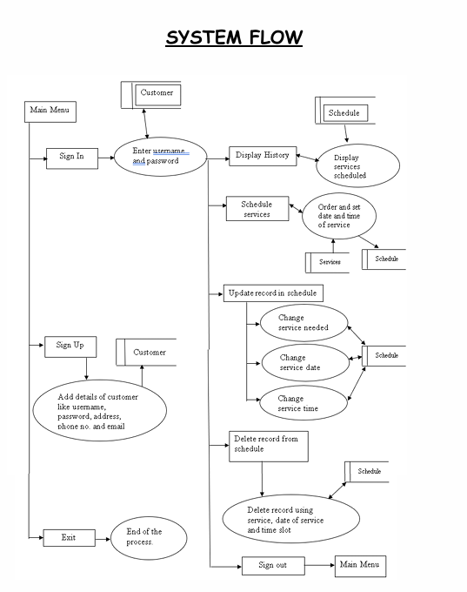

**SYSTEM DESCRIPTION**

The Home service and Personal care Application is an online marketplace that connect service providers with service seekers .The platform helps customers book reliable and high quality services like- beauty treatments, massages , home cleaning , appliance repair , paint , pest control and more - delivered by professionals conveniently at home. This project starts up with a welcome screen and proceeds to the main menu. The main menu has several options that are listed below –

**1. SIGN IN (LOGIN):** If the user has already created the login credentials then the user can login using those credentials.

**2. SIGN UP (REGISTER):** If the user has not created login then the user can create one using this option.

**3. Exit:** Can come out of the project.

Once the user has successfully logged in then the menu below will be displayed:

**1. Display History:** Under this option user can see his previous schedules and services taken previously.

**2.Selection of Services:** services to be delivered can be selected by the user .

**3.Scheduling:** Under this option the user can pick the date and time for appointment.

**4. Payment:** Under this option it shows the total bill.

**5.Update Schedule:** Under this option user can update his schedule.

**6.Cancel service**: Under this option user can cancel services he had opted

**7. SIGN OUT:** Under this option the user can come out of the current login.

**Database:**

* In this Home Services and Personal Care Application, I will use SQL/MySQL to create and manage a database that securely stores essential information, including user credentials, booking history, available services, and payment details.
* Databases are vital for this project as they allow efficient organization, retrieval, and updating of user information, ensuring data persistence even when the app closes.
* By using a relational database, I can structure the data to maintain relationships between different types of information (like users, services, and schedules), enabling a smooth and reliable user experience for booking, tracking, and managing services.

**Libraries Used**

1. **mysql.connector**:
   * This library is used to connect to the MySQL database and execute SQL queries. The mysql.connector module provides the necessary tools for interacting with a MySQL database from Python.
2. **string** (implicitly used):
   * Used for basic string operations like formatting and concatenation when building SQL queries and user messages.
3. **input()**:
   * Used to interact with the user, allowing them to provide input (e.g., username, password, service details).
4. **print()**:
   * Used to display messages and results to the user (e.g., menus, status updates, error messages).
5. **cur.execute()** and **cur.fetchall()**:
   * These functions from the mysql.connector library are used to execute SQL commands and fetch results from the database. For example, cur.execute() runs a SQL query and cur.fetchall() retrieves the result set.
6. **con.commit()**:
   * Used to commit any changes made to the database, such as updates or deletions, ensuring that the changes are saved.

**Database Structure**

The code assumes a MySQL database named ps, with the following tables:

1. **customer**:
   * Stores customer details such as user_name, passwd, address, ph_no, and email.
2. **services**:
   * Contains details of available services, such as service_name and rates.
3. **schedule**:
   * Stores customer schedules, including user, service, service_date, Time_service, and Total_bill.

**Code Explanation (Core Sections):**

* **login() and sign_in()**:
  + The login function checks if the username exists and validates the password. The sign-in function registers a new customer in the customer table.
* **schedule()**:
  + Allows customers to select a service, provide a date and time, and calculate the total bill. This function inserts the customer’s service schedule into the schedule table.
* **update()**:
  + Provides an interface for users to update the service schedule. It includes options to update the date, time, or service and adjusts the total bill if the service is changed.
* **delete_details()**:
  + Allows users to delete specific records based on service, date, or time.

**SCREENSHOTS**



